**Course Methods Test 1 Year 12**

Student name: ________________ Teacher name: ________________

**Task type: Response**

**Reading time for this test : 5 mins**

**Working time allowed for this task: 40 mins**

**Number of questions: _____6______**

**Materials required: No Cals allowed at all!**

Standard items: Pens (blue/black preferred), pencils (including coloured), sharpener, correction fluid/tape, eraser, ruler, highlighters

Special items: Drawing instruments, templates, notes on one unfolded sheet of   
A4 paper single sided,

**Marks available: 34 marks**

**Task weighting: 13%**

**Formula sheet provided: no, but formulae listed on next page.**

**Note: All part questions worth more than 2 marks require working to obtain full marks.**

Useful formulae

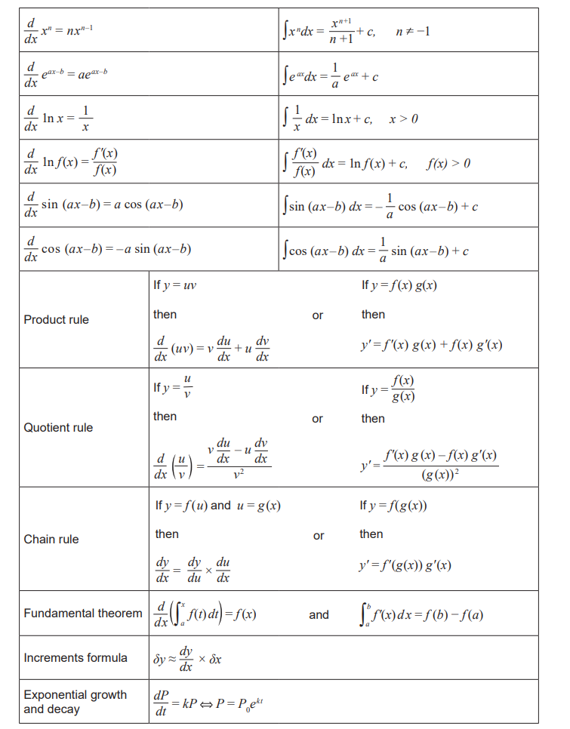

**No calculators allowed!!!**

Q1 (2, 2 & 2 = 6 marks)

Determine the gradient function for each of the following.

1. 
2. 
3. 

Q2 (4 marks)

Determine the equation of the tangent to the curve at the point .

Q3 (2, 2, 2 & 4= 10 marks)

The table below contains the values of the polynomial function  and its first and second derivatives for .

There are no stationary points for non-integer values of .

|  |  |  |  |  |  |  |  |
| --- | --- | --- | --- | --- | --- | --- | --- |
|  | 0 | 1 | 2 | 3 | 4 | 5 | 6 |
|  | 12 | 5 | -2 | -13 | -20 | -35 | -5 |
|  | -4 | -12 | -5 | 0 | -11 | 0 | 15 |
|  | -8 | 0 | 2 | 0 | -5 | 7 | 10 |

1. Evaluate  when 
2. Evaluate  when 
3. Evaluate  when 
4. Determine the x-coordinate of any **stationary** points and their nature. Justify your answer.

Q4 (3 & 3 = 6 marks)

Consider the curve of which is graphed below.

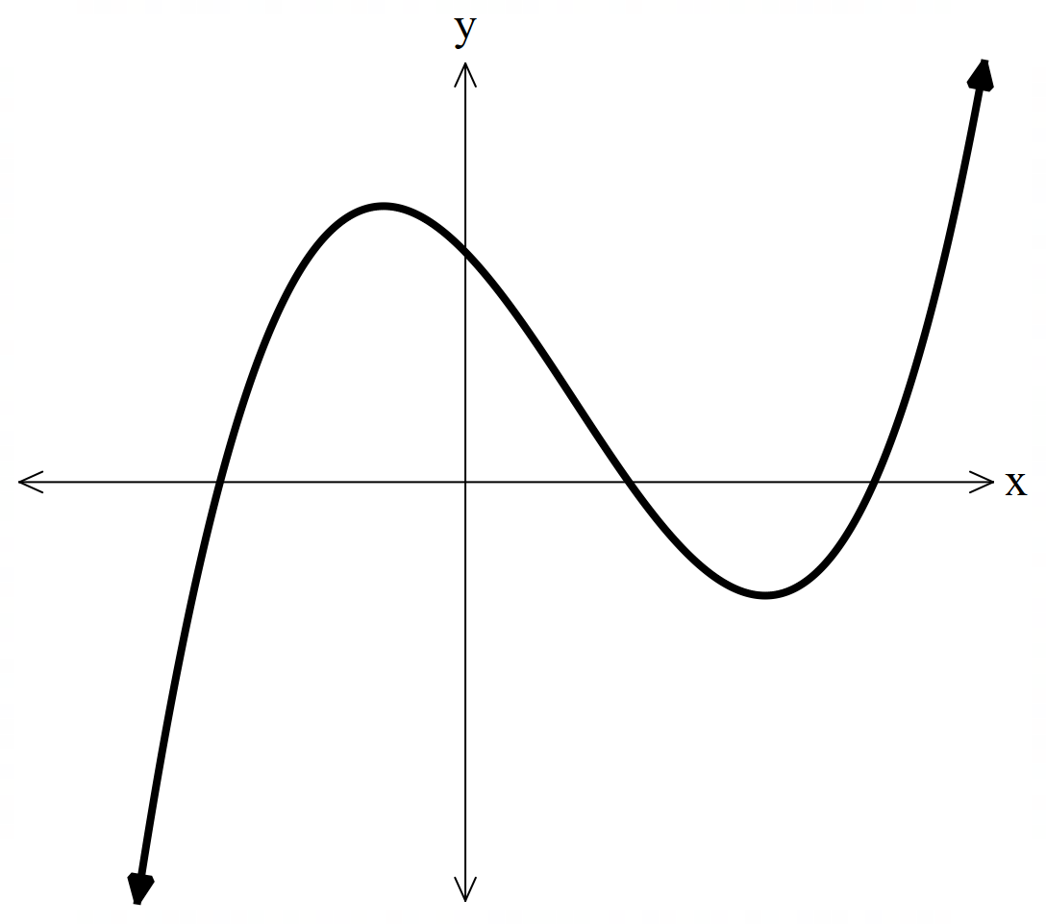

1. Sketch below a graph of the first derivative of . Label on this new graph stationary points.

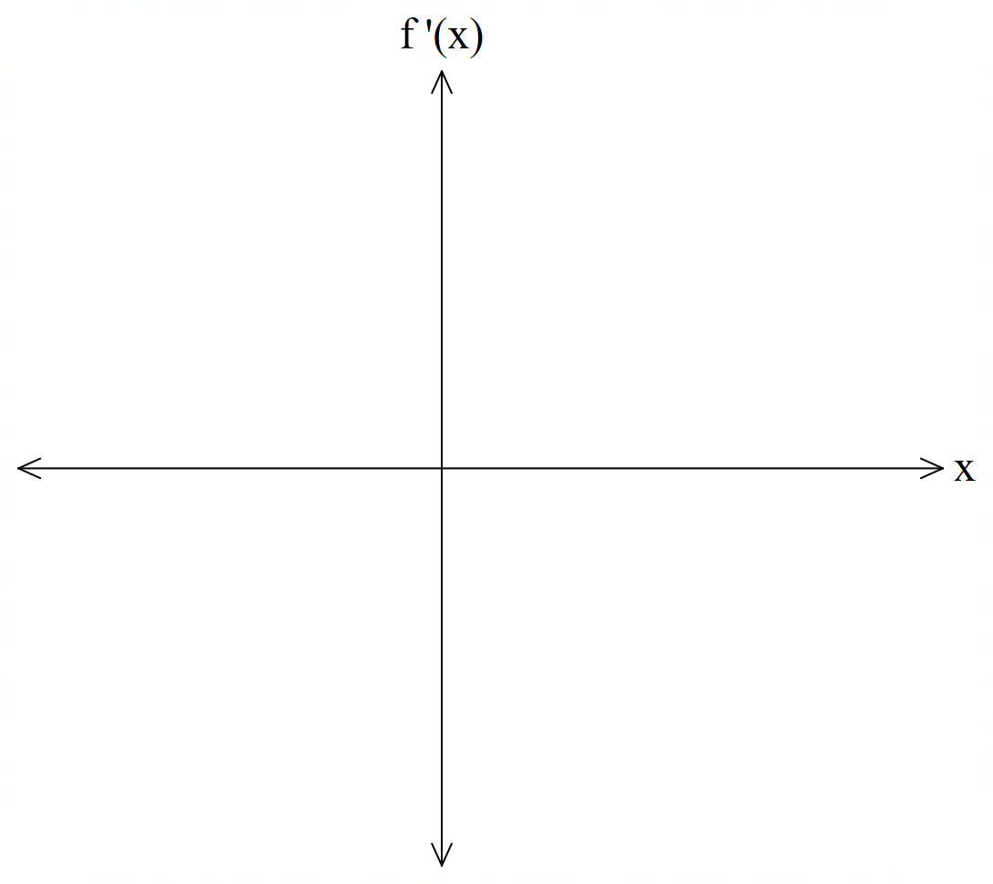

1. Sketch below a graph of the second derivative of . Label on this new graph any inflection points( if any).

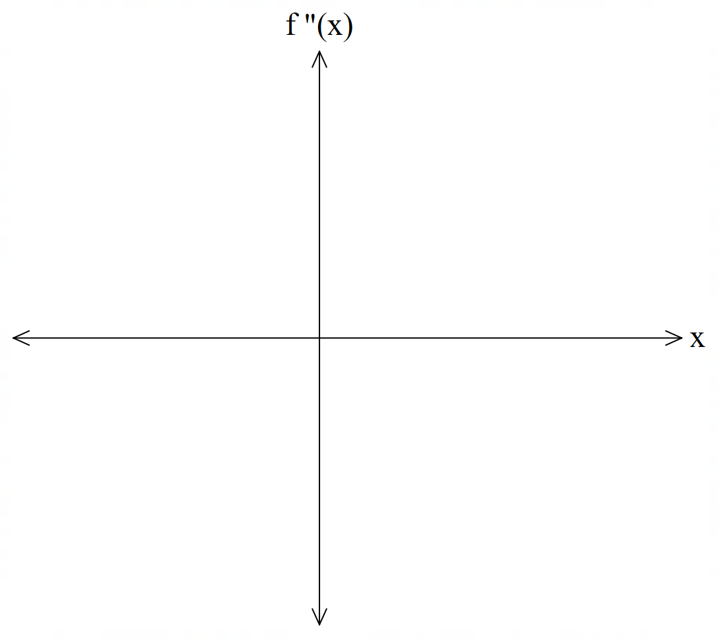

Q5 (4 marks)

The cost  for the production of thousands units of a certain product is given by

 , .

Determine the number of units for which the **average cost per unit** is a minimum and find this minimum average cost. Justify. (No need to simplify)

Q6 (4 marks)

Consider a train moving in a straight line. The displacement,  km, from its starting position at time  minutes is given by  , . The train changes direction twice. Determine the distance in km between these two positions on the track. (Simplify)

Working out space

Working out space